INSTITUTO MEXICANO NORTEAMERICANO DE CULTURA

Course Examination

1st Examination

Teacher’s Name: Adriana Felisa Chávez De la Peña

Student’s Name: _____________________________________

2.- **Numbers**. Write the name of the numbers below.

a) 8 __________________________

b) 17 __________________________

c) 50 __________________________

d) 749 __________________________

e) 2,865 __________________________

2.- Complete the blank spaces with the right word.

a.- Afirmative: Mónica studies all day long

1. Question: _____ (Does/do) Monica study all day long?

2. Answer: a)Yes,___ _____ (he does/ she do/ she does)

b.- 1. Question: _____ ____ __ Yoseph Angel? (What color is/How old is/Why is he called)

2. Answer: Yoseph Angel ____ (is/are) 11 years old

c.- 1. Question: Hoy ______ (much/many)do you love your mother?

2. Answer: I love my mother very _________ (much/ many)

d.- 1. Question: _____ (Does/Do) Carlos like to play soccer?

2. Answer: Yes, ____ _______ (He does/ She does/ He do)

e.- Question: _____(Do/Does) you think the class is boring?

Answer: Yes, ____ ________ (I does / They do / He does / I do)

3.- Write the name of these people’s job. **What do they do?**

a)  b) c) 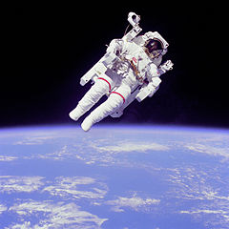

__________________ _______________________ ________________

d)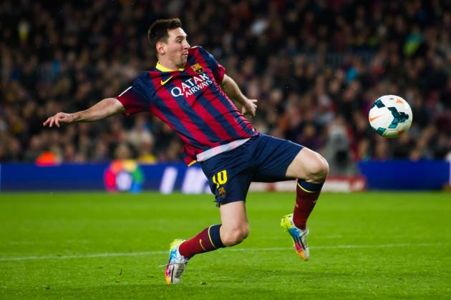 e) f)

______________________ ____________________ ___________________

4.- Match the columns below according to the translation of the Basic Questions in English.

|  |  |
| --- | --- |
| 1. Who | a) ¿Cuándo? |
| 2. Where | b) ¿Cómo? |
| 3. What | c) ¿Quién? |
| 4. Why | d) ¿Qué? |
| 5. When | e) ¿Dónde? |
| 6. How | f) ¿Por qué? |

5.-Complete the next chart, using the corresponding form of the verbs below

|  |  |  |  |
| --- | --- | --- | --- |
| Verb | Simple Present | Past | Present Continuous  (ing) |
| Play | a)Yo | b)Tú | c) Él |
| Walk | d)Tú | e)El | f) Ella |
| Teach | g)Él | h)Ella | i) Nosotros |
| Teach | j)Ella | K)Nosotros | l) Ustedes |

6.- Dictation: Numbers

**A N S W E R S H E E T**

INSTITUTO MEXICANO NORTEAMERICANO DE CULTURA

Course Examination

1st Examination

Teacher’s Name: Adriana Felisa Chávez De la Peña

Student’s Name: _____________________________________

1.-

a.1_________________ b.1_____________________ c.1____________________

a.2_________________ b.2_____________________ c.2____________________

d.1___________________ e.1_____________________ f.1____________________

d.2___________________ e.2_____________________ f.2____________________

2.-

a.1___________________ b.1_____________________

a.2___________________ b.2_____________________

c.1___________________ d.1_____________________

c.2___________________ d.2_____________________

3.-

a)_________________ b)_____________________ c)____________________

d)_________________ e)_____________________ f)____________________

4.-

1 ____ 2 ____ 3 ____ 4 ____ 5 ____ 6 ____

5.-

a)___________________ b)_____________________ c)____________________

d)___________________ e)_____________________ f)____________________

g)___________________ h)_____________________ i)____________________

j)___________________ k)_____________________ l)____________________

6.-

a)_____________

b)_____________

c)_____________

d)_____________

e)_____________

f)______________